Q1. Write a java program to take input Student information from the User and print it on the screen.

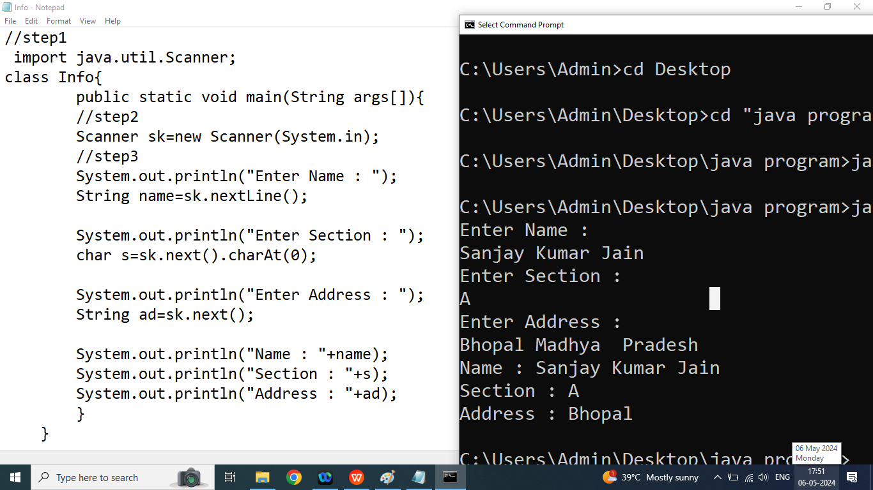

Q2. Write a java program to take Employee Infromation from the user and print it.

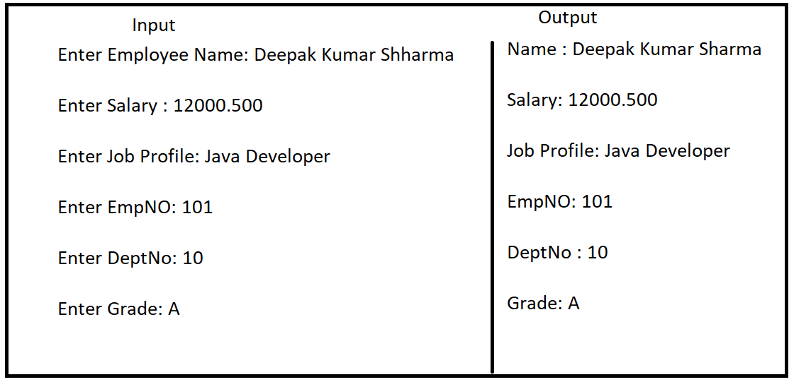

//step1:

import java.util.Scanner;

class Emp{

public static void main(String args[]){

//step2:

Scanner obj=new Scanner(System.in);

System.out.println("Enter Name of the Employee : ");

String name=obj.nextLine();

System.out.println("Enter Salary : ");

float sal=obj.nextFloat();

obj.nextLine();

System.out.println("Enter Job Profile : ");

String profile=obj.nextLine();

System.out.println("Enter EMPNO : ");

int empno=obj.nextInt();

System.out.println("Enter DEPTNO : ");

int deptno=obj.nextInt();

System.out.println("Enter Grade : ");

char g=obj.next().charAt(0);

System.out.println("Name : "+name);

System.out.println("Salary : "+sal);

System.out.println("Job Profile : "+profile);

System.out.println("EmpNo : "+empno);

System.out.println("DeptNo : "+deptno);

System.out.println("Grade : "+g);

}

}

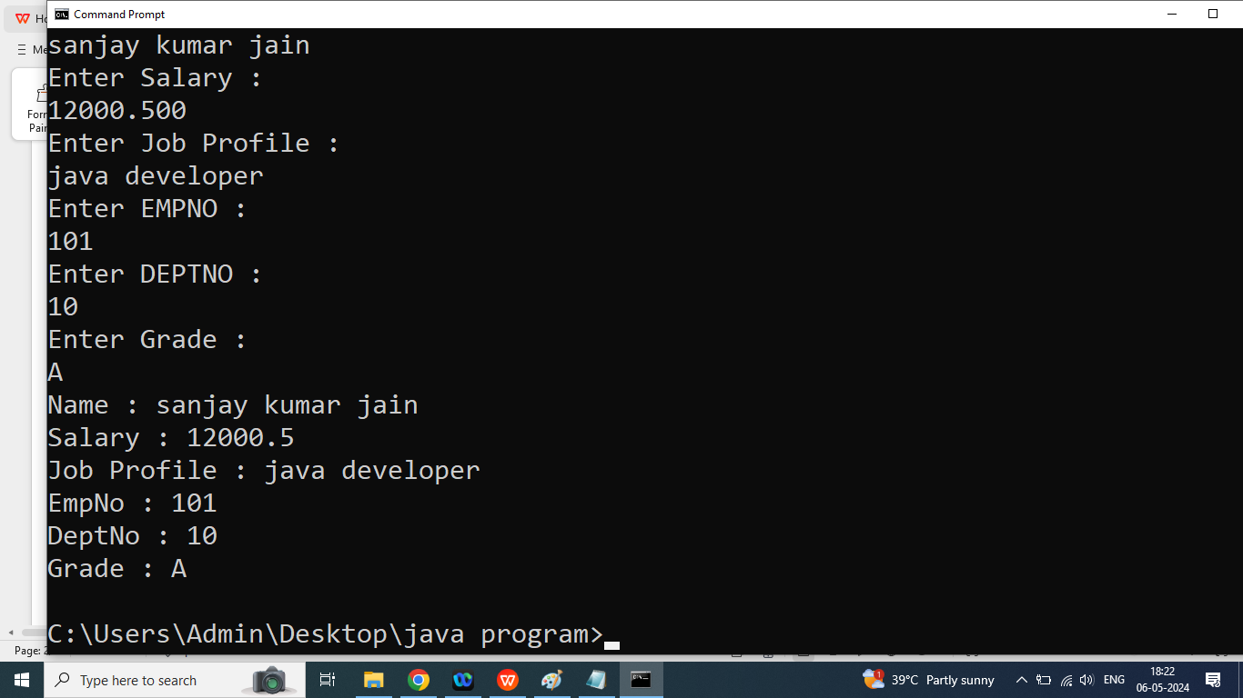

Q3. Write a java program to swap two numbers using third variable?

